**Database Design Document**

**1. Introduction**

This document outlines the design for the database schema for a concert ticket reservation system. The schema includes tables for storing information about concerts, booking windows, users, and ticket reservations.

I’m using PostgreSQL with credential below :

* Host:Port 🡪 localhost:5433
* Username 🡪 postgres
* Password 🡪 password
* Database name 🡪 edts

#### 2. ****Database Tables****

* **concert** 🡪 for storing concert detail
* **booking_window** 🡪 for storing total ticket sold and how many ticket can be sell in

certain time span

* **member 🡪** for storing member detail
* **ticket_reservation 🡪** for storing ticket reservation detail from member who buy it before

#### ****3. Table Structure****

#### 

#### 

#### 

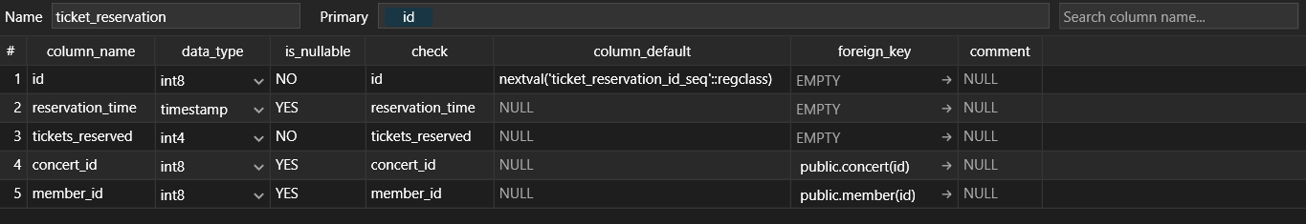

#### ****4. Dummy Data** In case want to insert dummy data for testing, just run this DML :**

INSERT INTO member (name, email, phone_number) VALUES

('User 1 ABC', 'abc@gmail.com', '081233334444'),

('User 2 DEF', 'def@gmail.com', '081344445555'),

('User 3 GHJ', 'ghj@gmail.com', '081455556666');

INSERT INTO concert (name, artist, location, date, start_time, end_time, total_tickets, tickets_sold, is_already_performed) VALUES

('Senayan Festival 2023', 'Katy Perry', 'Gelora Bung Karno', '2023-08-20', '17:00:00', '20:00:00', 10000, 0, true),

('Senayan Festival 2024', 'JKT48', 'Gelora Bung Karno', '2024-08-20', '18:00:00', '22:00:00', 10000, 0, false),

('Konser Jakarta 2024', 'Peterpan', 'Jakarta International Stadium', '2024-08-21', '19:00:00', '23:00:00', 5000, 0, false),

('DWP 2024', 'Alan Walker', 'Indonesia Arena', '2024-08-22', '20:00:00', '23:00:00', 8000, 0, false);

INSERT INTO booking_window (concert_id, start_time, end_time, max_tickets, tickets_sold) VALUES

(1, '10:00:00', '10:20:00', 1000, 0),

(1, '10:30:00', '10:50:00', 2000, 0),

(2, '14:00:00', '14:20:00', 500, 0),

(3, '15:00:00', '15:20:00', 1500, 0);

INSERT INTO ticket_reservation (concert_id, member_id, reservation_time, tickets_reserved) VALUES

(1, 1, '2024-08-20 10:05:00', 2),

(1, 2, '2024-08-20 10:15:00', 1),

(2, 3, '2024-08-21 14:10:00', 3);